Ashoka Edicts

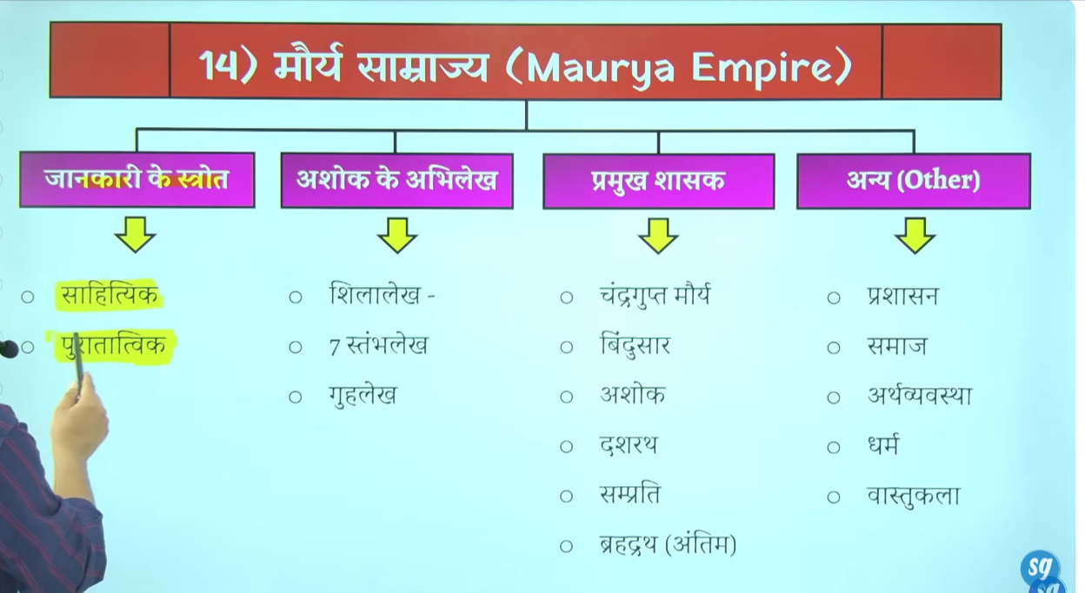
Ashoka pahla shaahsk tha jisne bade paimaneper abhilekho ko utkerna karwane ke pramapra shuru ke aur archaeological evidence chode inscription ko inscribe karne ka tradition shuru kyia tha ye usne persian ruler Darius first se sikha tha baad me usne bharat meusko implement kyia
Ashoka ke bahut sare sheelalekh hai rock edict pillar edict and cave edict Ashoka ke bahut sare isthamb lekh, guha lekha aur pillar edict hai jinse hume multiple information milte hai
Seelalekh= rock edict
Isthamb lekh= pillar edict
Guha lekh= cave edict

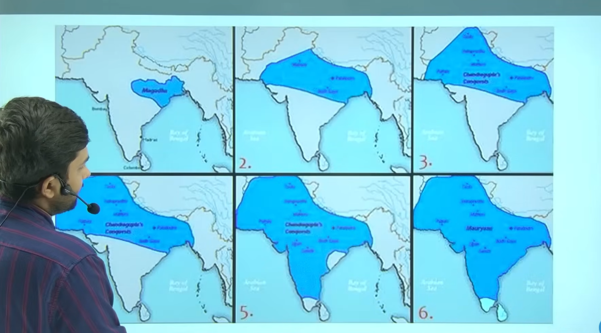

Mauryan samrajya india ka first empiro tha chadnrgupta Maurya who is the founder of this emperor indias first historical emperor wo bharat ke pahle ethehashek samrat the ith=ne bade Chetra per dubara kese bhe shashak ne shashan nahi kyia yaha tk angrej bhe jb bharat per shaahan kar rahe the to unka area bheitna badan ahi tha

Assam srilanka, tamilnaidu kashimir laddhak ka kuch ilaka ye ilakao ko chodkar lagbhag pure ke pure iladke me chandrgupta Maurya ka adhkr tha
Chandr ane selecus nicater ko harya aur use use pura afganistan wala Chetra mil gayay jaha per alexdener ne kabja kyia tha age Ashoka ne bahut sare vjiya abhyian kyie Ashoka ne bahut sare terrootry per kabja kar lyia
To uttar pashcim, daskhin purva me bahut bade samrajya ko isthapet kyi tha muaryo ne
To ye yad rakhne wale bat hai ke Maurya samrajya ek vishalkaay samrayjya tha itna bada samrjay fir bharat me dubra kabi nahi hua
Sabse pahle hume ye samjhan hoga ki in ke Jankari hume kahan se milte hai source of Mauryan emperor

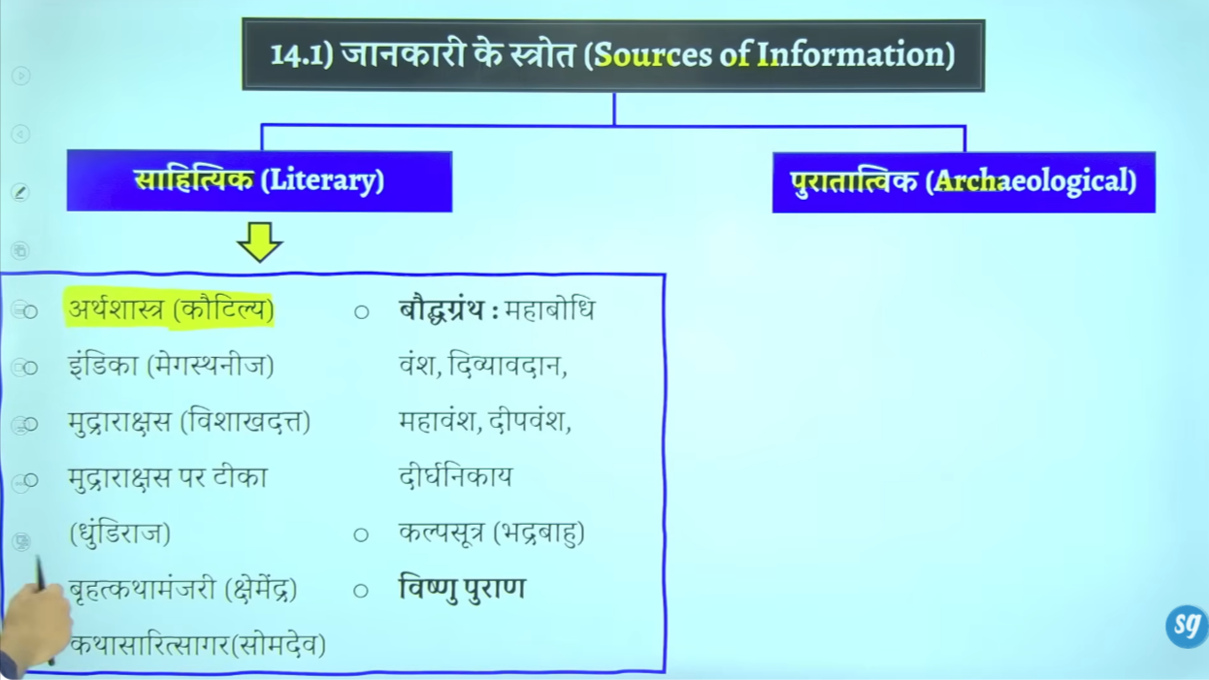

History ko jaanne ke do source hote hia ek to literary second is archaeological source
Chandkya = Chandra ke pradhanmantri the aur kuch samya ke lyie bimbisar ke mantri the inhone governance ke uppar polity ke uppar book likhe the arthsahsthra jisse hume Maurya kaal ke poltical and social information milte hai rajnatek vyvastya ke jankari milte hai
Megasthaneez celus nicatrr ka raajdoot tha jo chandr ke darbar me lambe samya tak rahah isne indica nam ke booklikhe
Mudrraksha se is baat kejankari milte hai kaise Chandra nanda ko dynasty se hatya aur Mauryan vansh ke isthapan ke
Deergh nikaya jaha ashok ne dhamm ko parebhashet kyia
Jain granth kalpsutra bhadrbahu ke swara likha gaya aur ekaur jain granth hai parsestparman
Vishnupuranse hum maurynon ke jankari milte hai
Vauypuran se hume gupto ke jankari milte hai

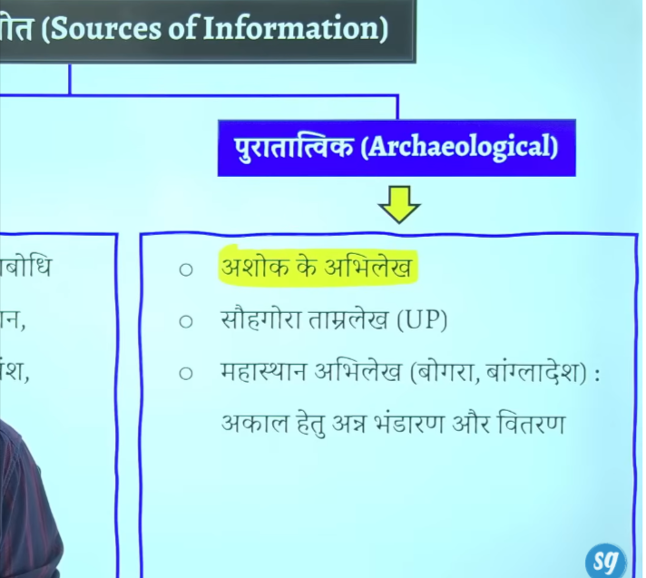

Ashoka ke inscription jisse hume Maurya kaaal kejankari milte hai Ashoka ke sare abhelekh prashasn se jude hue hai except rummandei rummendei se Ashoka ke taxation ke information milte hai except this all are related with administration

Sohgaura and mahstha se pta chatla hai ke magadh wale ilake me akal femaine aya tha 12 varsho ke lyie us akaal se nipatne k lyie raja nea apne ann bhandar ka proyog kya ek prakar ke rashan vyvastha ka prayog kya means har vyakti ko nischit matra me anaj dyia jata tha
Ye magadh me akala ke jankari dete hai anna bhandar ke jankari dete hai aur anaj ke vitaran ke jankari detehai they give infroration 12 yearlong draught in magadh distribution of grain like rationaing system

Do kitae bahut mahtvapurna hai arthsahstra and indica

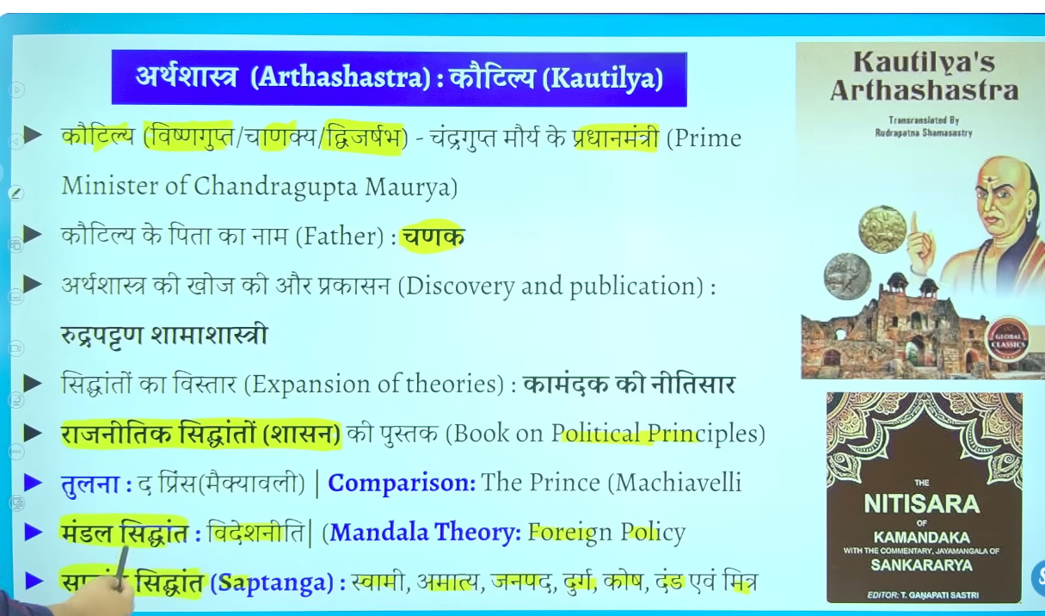

Chakya ke bachpaan ka naaam Vishnu gupta tha he was the pm and teacher of the founder of Mauryan emperio and also kuch samay ke lyie bimbisar ke bhe pm the
Inhone book likhe the arthashatra it is the book of polticalprincipal especially about the governance ye book economy ken ahi hai

Jaise is book me sapt sidhant dyia gayay and mandal theory

Mandal teory is related to froeign olicy sapt sidhan me batya ke ek shashan me kinte mahtvapuran ang hote hai

Jinko chankya sapt ang bolt hai ye itnem mahan pustak hai ke iske tulna maichavale dwara likhe gae book the prince seke jate hai
Kae baar kautilyako maichavalee of india bhe bola jata hai

Arshtsahstr book of chankya k khoj r samamasahstri neke afir iska publication kyia ye Sanskrit ek bahut bade vidwan the to ye question pucha jata k eke arthasathr ak adhunki praksh kisne kyai tha to sahanskr ke mahan schoolr r samasaharti

Kamandak ne arthsahstr ke book ke sidhanto ko adahar bante hue ek book likhe the niti sar
To kamandak ki book ka adhar tha kautilyia ke dwara likhe gae arthshsatra
Chankya chanra and bimbisar ke prim minister the

Kautilya ke arthashatra se hum maruya kaal ke prashashnik administrative information milte hai halaki samaja and arthvayavsth ke bhe charcha arthshastra me keg ae hai
To kautyria ke arthshtra se hum Mauryan and pre Mauryan timeke political adminstrativ information althous we also obtain the information about ecomoay and socity of that partiucar tim perido

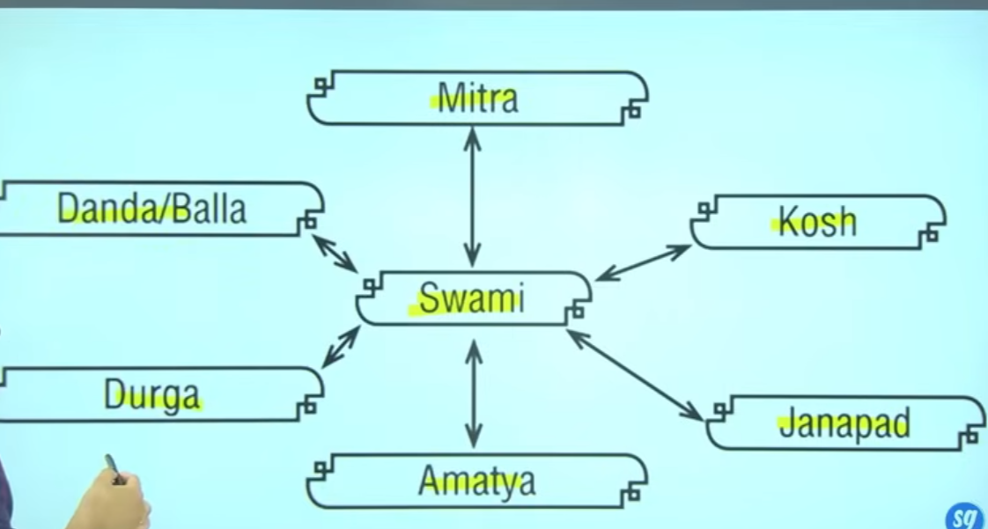

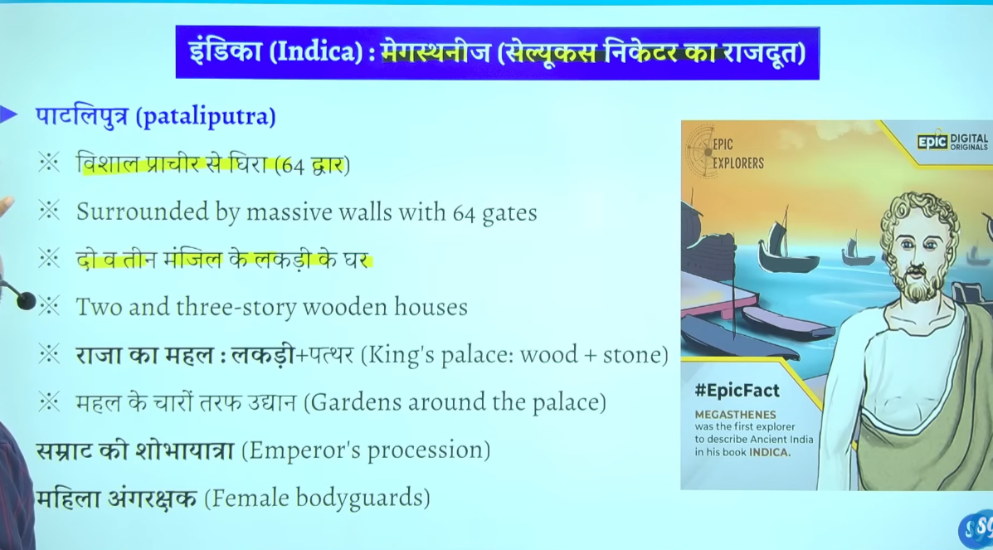

Ambasoddr of celus nicater megasthneej
India me usne likha tha ke jo raja kah mahal hai wo bahut vihsal kaya mahal ais shunadar mahal dunyia me kahenahi bana hua hai raja ka mahal wood se bana ha aur kahe kahe stone bhe use kyai gaya hai usne liha hai ke rajah jb bahjr jata hai apne shobaha yatra me to ek baide paimane per ek jalus sa nikalta hai rjaj ke angraksha jo hai wo mahilaye hote the patliputra ke bare me wo bahut jankari deta hai
Usen batya patliputra ka fortification kyia gya jisme alag alag 64 gate hai ye sare bate usne indica melikhe the
Celuse nicater ambasoer is megasthenj who came during the rule of chrnagupta Maurya

Vishakadutta ne mudrarkasha likhe aur ye gupta timeperido me likhe gae the usem usne batya tha ki skias chandya aur Charan gutpa Maurya mil kar ke nanda vanshka overthrown karte ahi nand wansh ke antim shsahs dhanandna ko gaddi se hata dyia tha

Chndragutpmaryan and seleucs nicatrer ke beech me ladae hue the us lade me chnagrutpa Maurya jeta tha faur fir celuse nicater ka rjddot megasthenej bharat ata hai aur lambe samayt tk bharat merhah waur usne jo bhe jankari us time ke bare me ekaddha ke wo apne book indica me likh de

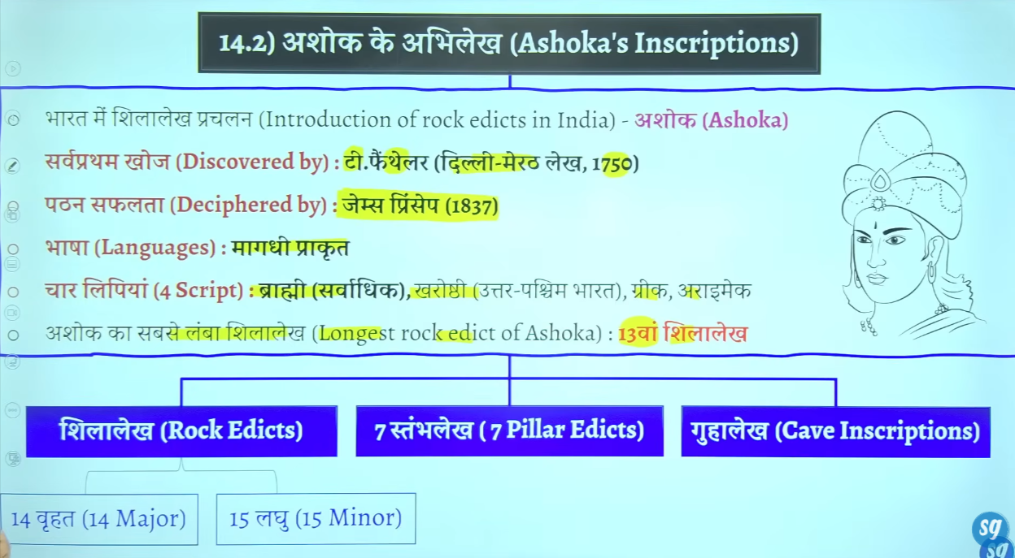

Abheelkeh ka matlab hai ki koi bhe patharya dhatu jis per hum kuch lekh dete hai to usko abheelkhe kahte hai
Abheelekh kaee prakar ke ho sakte hai jaise ke apne ek Chattan ke uppar likh deyia to usko hum sheelalekh bolte hai
For apne ek pillar isthamb banyawa us per kuch likh kdyia to usko pillar inscription bol dyia tha fir agar apne kise gufa me jaka rkuch likh dyai to usko hum cave edict guha lekh bolenge

Bharat me inscitpion ko prachalet karen wale peson ka naam he Ahsoka hai jisne Darius first persioan ruler se y cheez sikhe the
India me bharat me Ahsoka ne bahut bade paimane me rock inscription banwae the

Ashoka ke inscription ko teen bhago me divide kyia gayay hai
1 rock edict
Pillar edict
Cave edict

Ashoka ne apne abhilekho me prakrat bhasah ka prayog kya hai aur prakra me bhe magadhi prakrat ka use kyai hai
Jaise ajj hum hindi bolte hai to hindi ke bahut sare alag alag ruoop haiwaise he prakrae ke bhe bahut sare version the

Aur kahe kahe Greek aur armaeck langaue ka bhe usek kyia hai
Hum hindi bolte hai ye hamare bharsa hia humlikhte devnagri me hi jo ki lipi hai
Lipi
Ashoka ke 90% se adhik abhelekho me brahmi lipi ka prayog hua hai brahmi is the primary scripti fo the Ashoka edicts uske alwas kharoshi aur armace lipi ka bhe proyog hya hai
Bharat ke antreek bhato me jinte bhe abhilekh mile hai unme brahmi ka use hua hai
Aur ek do abhelkeh aise hai jisme armaeck limi use hue hai
Karoshit ka use north west Pakistan aftganistan wale region me khyia gya hi

To jab in lipi ka use kyi to bharat ke logo ko to ta nahi tha to kaun sa wo vyakti tha jisne Ashoka ke abheeelkho ko pada tha james princep wo vyakti tha 1837 me brahmi lipi ko pada
Ashoka ke abheelekho ke jankari hum 1750 me he mil gae the t faitherler ne jankri de the aur usne delhi-merath abhelekh prapt kyia tha
T faitherl pad nahi paya tha padne ka kaam kyia tha james princep ne

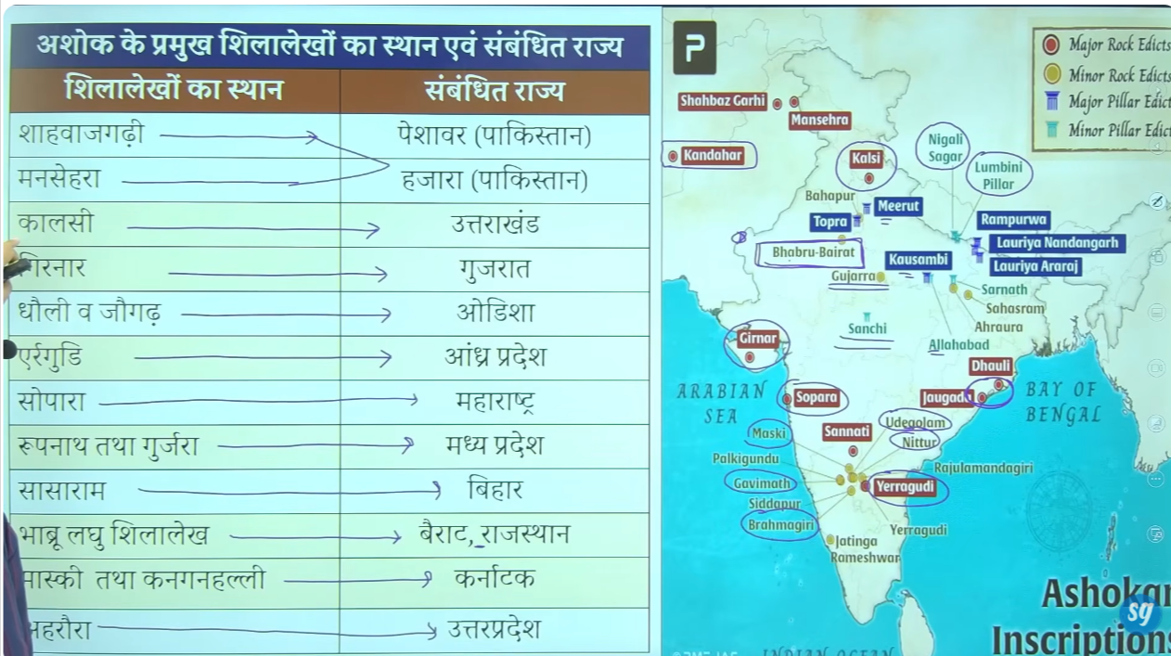

Maski gurjaara and kangaanahali me Ashoka ka name Ashoka likha hai
Bhabru se pata chalta hai ke Ashoka buddha damra ka anuyaee the
Paschim me Gujrat me jungarh rudrdmaan ka jungarh abheelkeh jo girnar wale ilakee me istheet hai yaha ek jheel bhe hai sdarshan jheel jo chandrguta Maurya ke mantri governor pushyamitra Vaishya ke dwara banwaee gae the

Baad me Ashoka ne rudrdaman, skandgupta ne iska jeerdondhar bhe kyia tha

Maski and nittur bahut important hai Karnataka me hai udegaolum ye karnatka me hai
Dhauli ordissa jaugada bhe odhissa
Kandhar afganisthan me ahi
Bhabru jisko bairat bhe bolte hai rajasthan me ahi

Nepalme do pramukh hai ek nigali sagar aur dusra Lumbini pillar

Nepal me 2
Pakistan me 2 afganisthan me 1
Up me 5 meradth kausshami prayrgaj sartnaht ahruaur ye 5 main hai aur bhe ho skte ahi check it

Odhisa me do important ahia dauli, jaugarh
Andrapradesh me yerragudi
Karnatak , - kanganhiali, maski, nittur, udegolom brahmagiri these are important in karnatka

Gujrat me girnar
Maharastra me sopara rajsthan, bhabru, ya bairat
Mp me Gurjara , sanchi, roopnath ka inscitpion
These are important

Rock edict and pillar edict ko two parts me divide kyia gay hai
Majaor and Minor these are classified inot tow parts major and minor

मौर्य सम्राट अशोक का नाम स्पष्ट रूप से मास्की (Maski) (कर्नाटक) के लघु शिलालेख में "बुद्धशाक्य" या "अशोक" के रूप में मिलता है। इसके अलावा, गुर्जरा (मध्य प्रदेश), नेत्तूर (आंध्र प्रदेश), और उडेगोलम (कर्नाटक) से प्राप्त शिलालेखों में भी उनके नाम का उल्लेख "अशोक" के रूप में किया गया है, जो उनकी 'देवानांपिय' उपाधि के साथ आता है।
Wikipedia +2
मुख्य विवरण:
- मास्की शिलालेख: यह 1915 में खोजा गया था और इसमें "देवानामपियसा अशोक" (देवताओं के प्रिय अशोक) अंकित है, देखें विकिपीडिया।
- गुर्जरा शिलालेख: इसमें "देवनमपिया पियादसी अशोक राजा" लिखा है, देखें विकिपीडिया।
- उपाधि: अधिकांश अभिलेखों में उन्हें "देवानांपिय" (देवताओं का प्रिय) या "पियादसी" (देखने में सुंदर) कहा गया है।
- अन्य साक्ष्य: कर्नाटक के कंगनहल्ली स्तूप में एक शिलाखंड पर "रान्यो अशोक" (राजा अशोक) का उल्लेख मिलता है, देखें {Link: Vision IAS में यह जानकारी के अनुसार है}।

सम्राट अशोक का व्यक्तिगत नाम मास्की (Maski) (कर्नाटक) के लघु शिलालेख में सबसे पहले और स्पष्ट रूप से मिलता है। इसके अलावा, 'अशोक' नाम गुर्जर (मध्य प्रदेश), नेतूर (आंध्र प्रदेश), और उडेगोलम (कर्नाटक) के शिलालेखों में भी पाया गया है। इन अभिलेखों में उन्हें "देवानांप्रिय" (देवताओं का प्रिय) के साथ "अशोक" कहा गया है।
YouTube +5
अशोक के नाम से संबंधित मुख्य तथ्य:
- मास्की (Maski): यहाँ के अभिलेख में "देवनमप्रियस्य अशोकस्य" (Devanampriyasa Asokasa) अंकित है।
- गुर्जर (Gujarra): यह मध्य प्रदेश के दतिया जिले में स्थित है जहाँ उनका नाम स्पष्ट मिलता है।
- अन्य नाम:
कंगनहल्ली (कर्नाटक) के शिलालेख में 'रान्यो अशोक' (राजा अशोक) कहा गया है

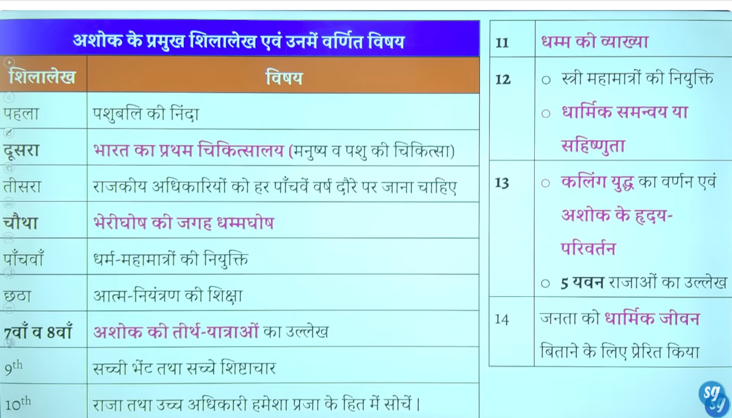
14 major rock edict of Ashoka
15to 16 minor rock edict hai

1 first me animal sacrifice ke ninda ke pure thara se animal sacrifice band nahi kyia gyaa tha but animal sacrividce ko reduce kanreki baat hue the
5th me animal sacrifice ko pure tarah se band karne ke baat hote hai
2nd me Ashoka is given the credit to buit first hospital in india for hostipal for human as well as animal
3rd me bola tha ke governemtn ke official ko har 5 ve varsh me apne Chetra ka duara karna chaye aur dekhna chaye ke sab kuch dekh hai ken ahi hai

4th me policy fo dhamghosa instead of berigosh berigosh me hinsa ke neite policy fo vionelende and dhamgahosa means policy fo non violendce and ahinsa ke niti

Ashoka kalinga yudh se pahle he buddha dharma ko apna chuka tha ahalik kalinga yudh ke bad usne dhaamghsoh ke niti apnae the

8th me Ashoka ne piligrmage kyai tha ubddha se jude haue sabhe isnath nigalisagar, bodgyaa, lumbani ke yatra ke the

11th me Ashoka ne lgoog ko logo ko moaral life jine ke niti ke vyaka ke hai jiske dhamm bhe bolte ahi Ashoka ne niyamo ke seires bane djia logo ko moral bane k lyie jise dhamm bote ha ye buddhism se nahi juda hai but buddhsimse prabhavit hai
Ashoka dhamma is mention in 11th rock edict

Ashoka Shurat me brahman dharma mko manta tha shaiv dharma komanta tha Ashoka ne devanampyia ke title lyia tha to devname pyia ke upadi wahe dharan karte hai jo brahmand dharma meashta rakhte hai aashoka ne buddhsa dhamr bahale he adopt kya but usne andya dharmko ka bhe samman kyia tha
Ajeevko k lyie bhirar me Barabar ke gufao me teen sailashraya banwaye use tharah se lomash rishi ke gufa bhe usen Barabar ke gufa me banwae ye dekhata hai ke Ashoka kudh sabhe dharma ka samman karta tha
12th me religios torerence ke batt hue thai

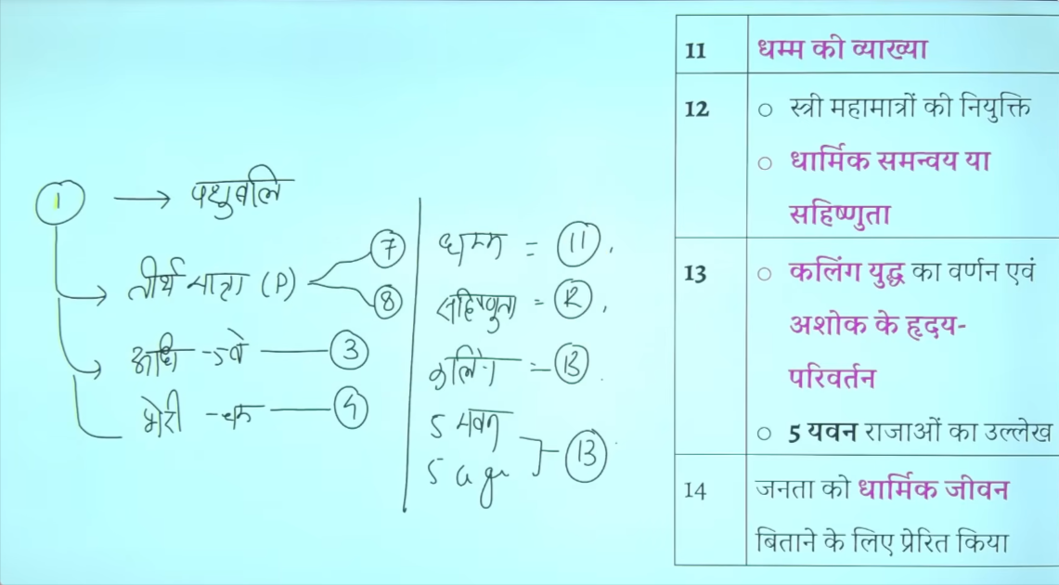
S bh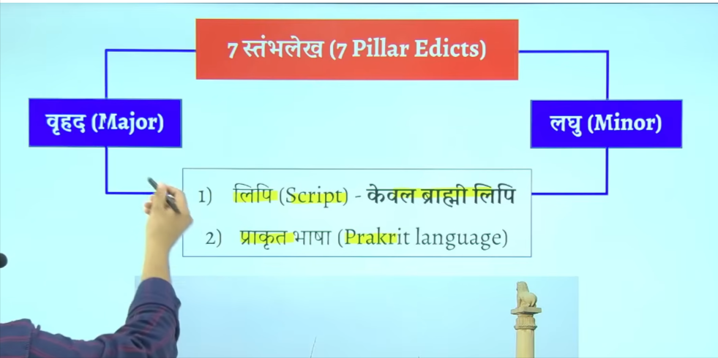

‘
Sheelalekho me hume alaga alag bhasay mile hai jais e kaee ajghao per bharat me brahmi kharoshi, armaeck

But pillars me brahmi limi and prakarat bhasa hai is bhasa ko hum magadhi prakrat bhasha bolte ahi
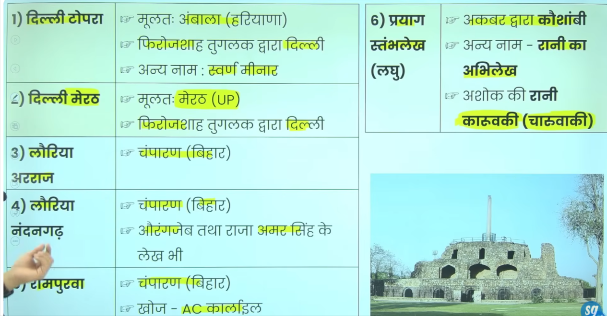

7 most pillar inscpiton
Delhi topra name isley hai kuki pahle ek abhelek math me aur topra me tha jisse delhi laya gya tha dono ko delhi lane ka kaam firoz shaha tuqlaq ne kyai tha

Inme baad ke rajao ne bhe apne jankaro ko add kara dyia tha jiase aurngaze amarsingh samduragutpa
Ashoka ne in lago ken ahi likha tha
Kaushambi ya rani ka abhilekha ya Prayag abhilekh ye teeno ek hai ye up me kausahbmi me hai pahle ye praygraj me tha akbar ke dwara isko kausambi me laya gaya tha iske ko rani ka abheelkh bolte hai kuki isme he Ashoka ke rani karuvaki ka ullekh hia jisse charuvaki bhe kahah jata hai

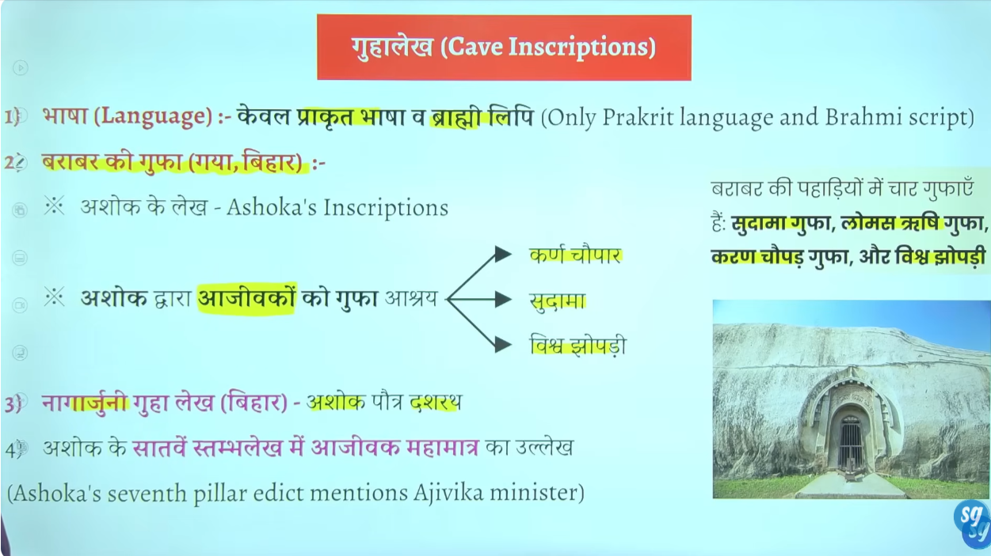

Ye gufa ke andar chattano me likhe jate the
Cae inscitpoin is also found in prakrat langaue and brahmi lipi
Jismebarabarkegufa bahut importanthai joke bihar me isth hai
Actuarly Barabar ke gufa me char alag alag gufaye hai
Jisme se teen ajeevoko ko de gae the ajevka sampradaya se sambahndeth hai
Kis rajaj ne ajeevak sampradya ke lyei bhir me gufaye banwae the to answer is Ashoka age jagakar ke Ashoka ka grandson dasrhath ne nagarjuni ke gufae banwae the wo bhe bihar me hai

Mahamatra kya hai to Ashoka ne apne dhammke shurat ke to dhamm ka Prachar karne k lyie mahamatro ko neyukt kyai tah
To ise tarah k mahamatra usne ajevka ka Prachar kane k lyie neyukt kye the
To Barabar and nagarjuni gufa bihar me hai ahsoke ne ajevko k lyei ten ashrya isthal banwae the

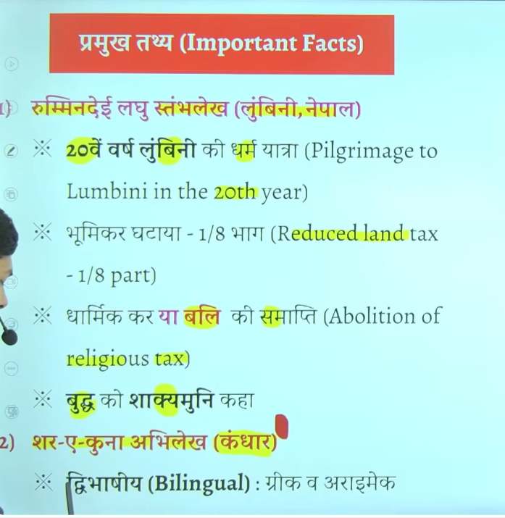

Usne land revenue tax ko bhe ghata dyia tha pahle upaj ka 1/6 hissa kar ke ruup me lyie ajta tha usne usko kam karke 1/8 kr dyia tha
हाँ, नेपाल का दक्षिणी भाग और काठमांडू घाटी सम्राट अशोक के शासनकाल (तीसरी शताब्दी ईसा पूर्व) के दौरान मौर्य साम्राज्य का हिस्सा थे। अशोक ने लुम्बिनी का दौरा किया था और वहां एक स्तंभ स्थापित किया था, जो इसके उनके साम्राज्य के अधीन होने का प्रमाण है।
विकिपीडिया +4
मुख्य तथ्य:
- अशोक का प्रभाव: सम्राट अशोक ने नेपाल के क्षेत्रों (विशेषकर तराई क्षेत्र) पर अपना अधिकार स्थापित किया और वहां बौद्ध धर्म का प्रचार किया।
- ऐतिहासिक साक्ष्य: नेपाल में लुम्बिनी, निगली सागर और गोटिहवा में अशोक के स्तंभ और शिलालेख मिले हैं, जो उस समय के मौर्य शासन की पुष्टि करते हैं।
- काठमांडू घाटी: ऐसा माना जाता है कि अशोक ने काठमांडू घाटी में प्रसिद्ध बौद्ध स्तूपों का निर्माण करवाया था।
- लिच्छवी काल: मौर्य वंश के बाद, नेपाल में लिच्छवी वंश का प्रभाव बढ़ा, लेकिन बौद्ध धर्म और भारतीय सांस्कृतिक प्रभाव बना रहा।
विकिपीडिया +2
संक्षेप में, नेपाल का दक्षिणी और मध्य क्षेत्र मौर्य साम्राज्य के सीधे प्रभाव में था।

Buddha ko rummanded abhelekh me shakymuni bhe kahah gya hai

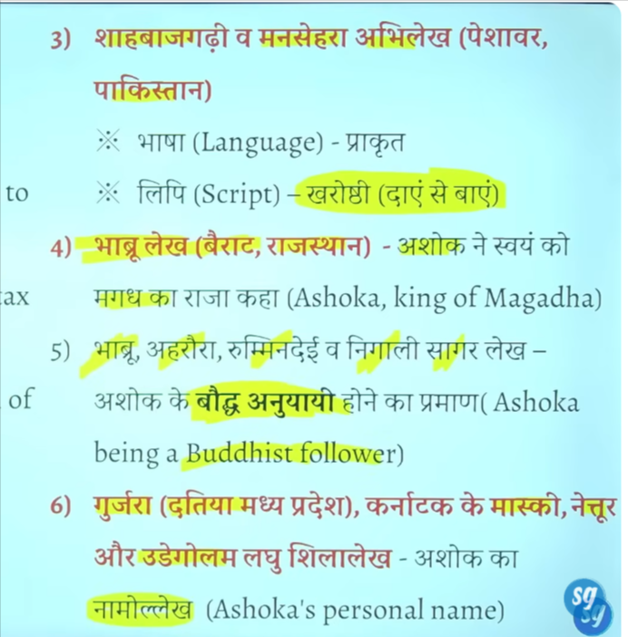

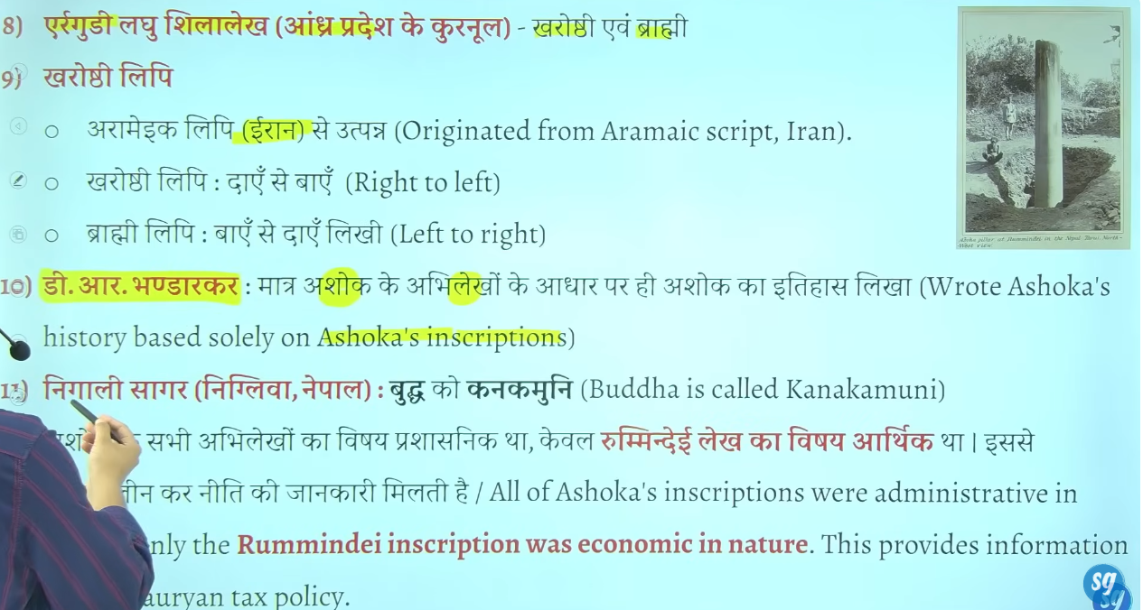
Ashoka ka pura ithhash abhilekho ke adhar per likha hai kise bhe archaleogil evidence ke help nahi le hai wrote entire history of Ashoka based on inscirtiopn
Buddha ko kanankmuni bhe kahah gya hai

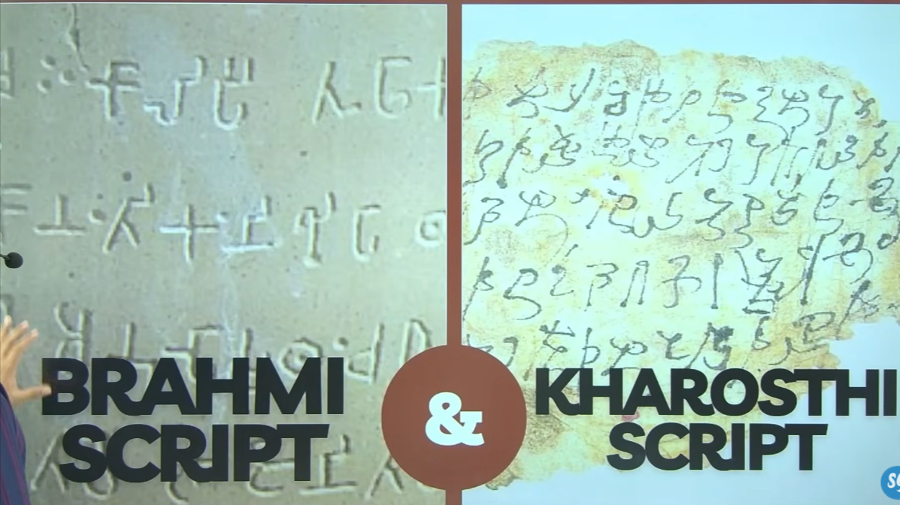

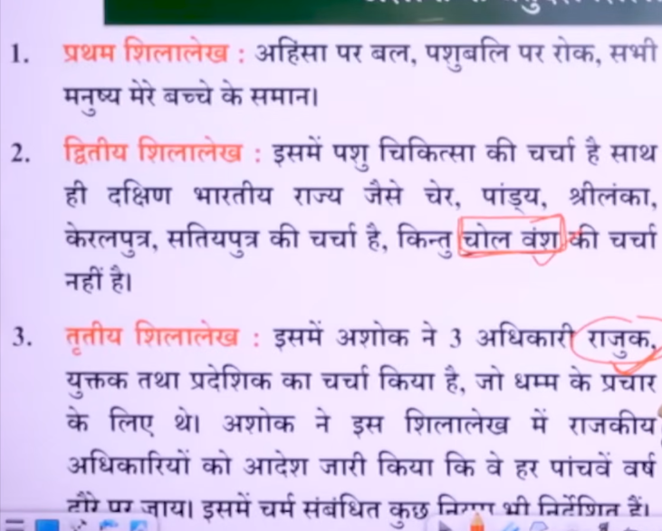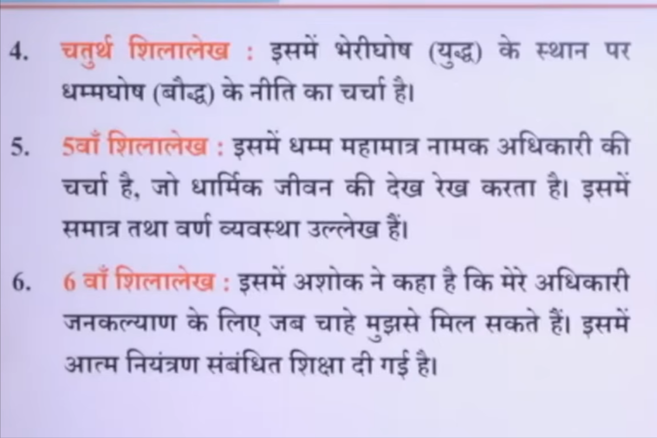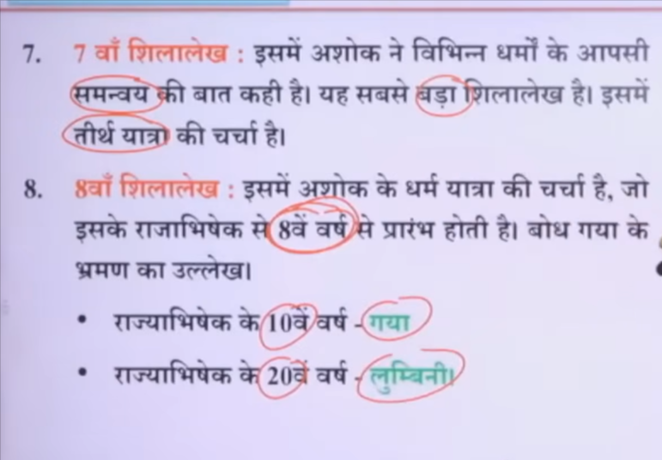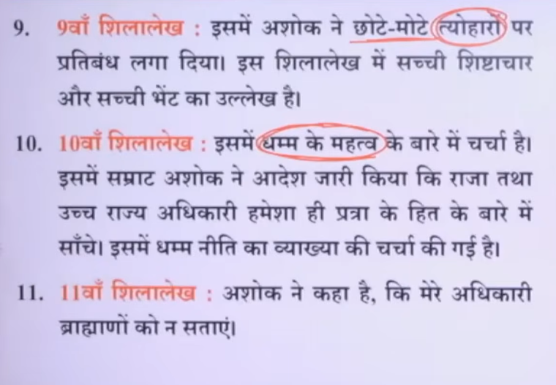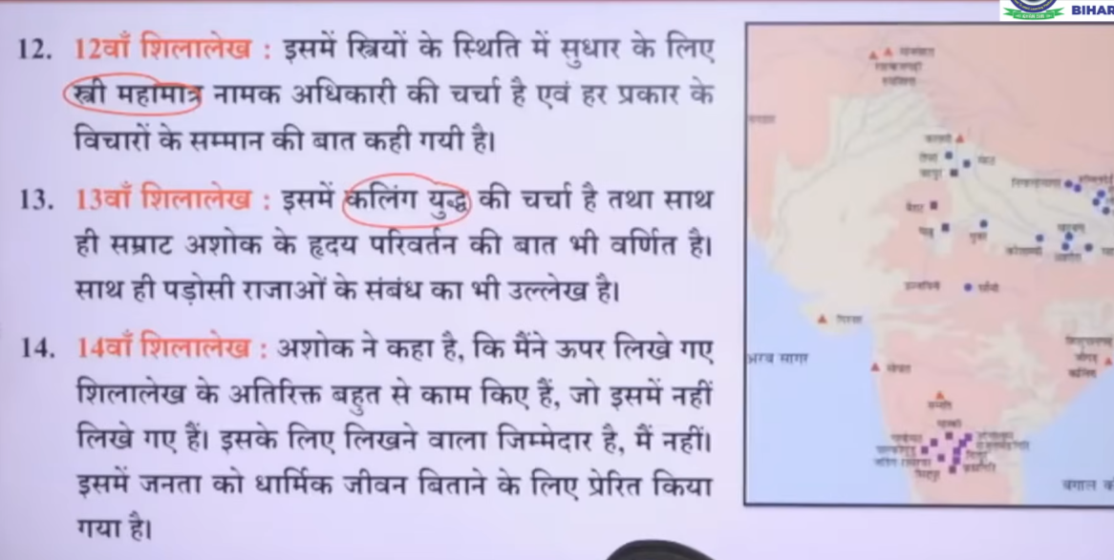

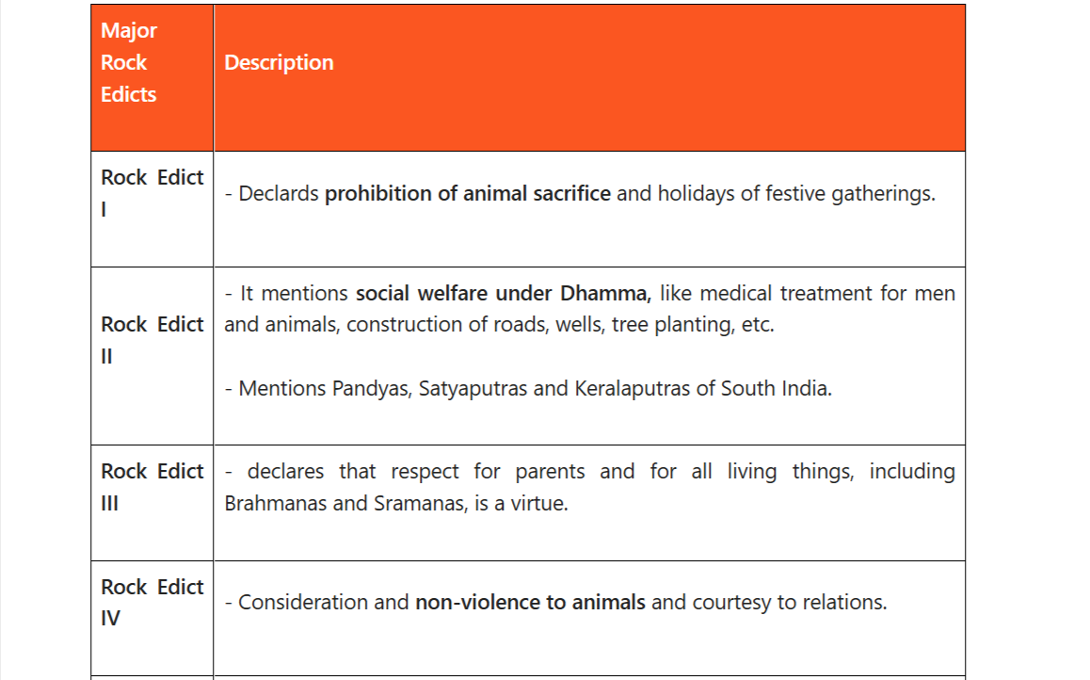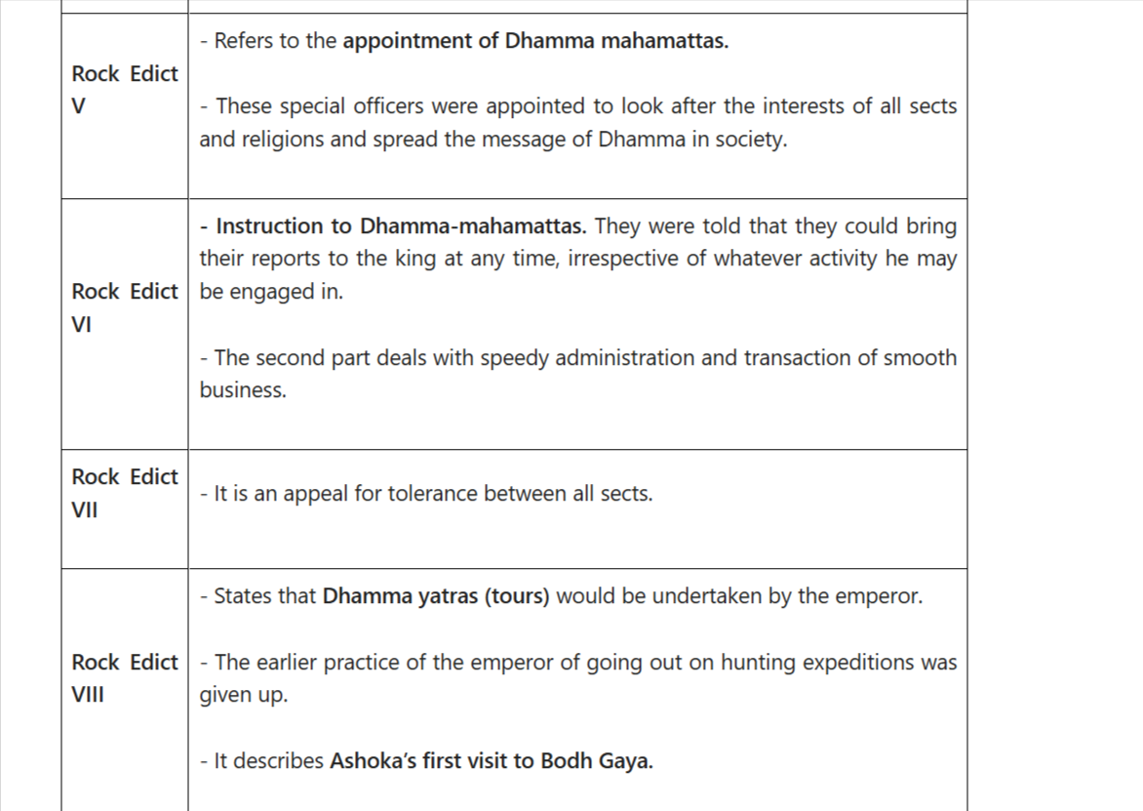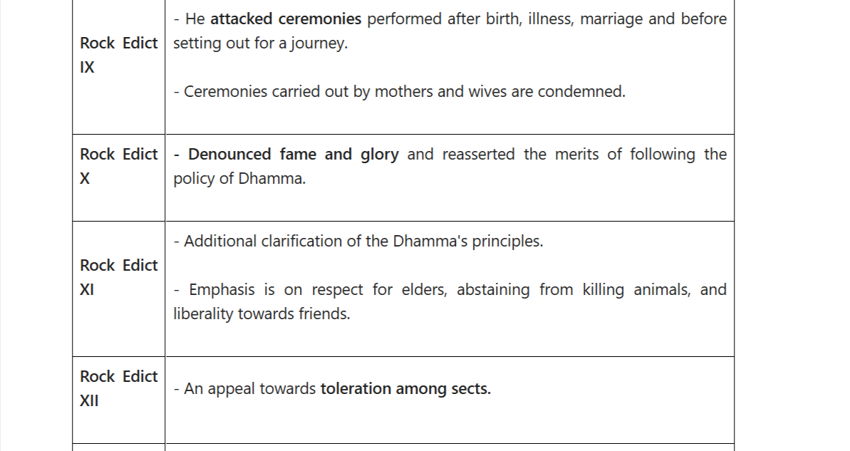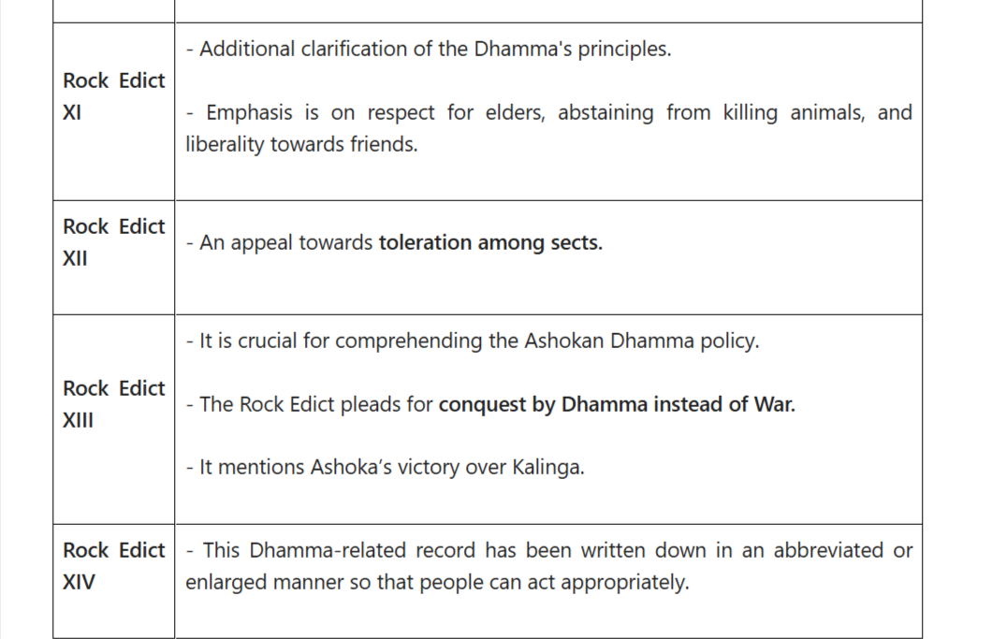

Here is a complete, structured explanation of the 14 Major Rock Edicts of Ashoka in both English + Hindi (easy Hinglish style) 👇

🪨 14 Major Rock Edicts of Ashoka
(अशोक के 14 शिलालेख)
These edicts were inscribed on rocks across the empire to spread Dhamma (moral law).

🔹 Edict 1
English: Prohibits animal slaughter and unnecessary sacrifices.
Hindi: पशुओं की हत्या और बलि देने पर रोक लगाई गई।
👉 Ashoka promoted non-violence (अहिंसा)

🔹 Edict 2
English: Provision of medical facilities for humans and animals; planting herbs, wells, roads.
Hindi: मनुष्यों और पशुओं के लिए चिकित्सा व्यवस्था, औषधियां, कुएं और सड़कें बनवाई गईं।
👉 Public welfare (जनकल्याण)

🔹 Edict 3
English: Respect for parents, teachers, Brahmanas, and proper behavior.
Hindi: माता-पिता, गुरुजनों और ब्राह्मणों का सम्मान करना चाहिए।
👉 Moral values (नैतिक शिक्षा)

🔹 Edict 4
English: Decline in immoral practices and growth of Dhamma.
Hindi: पाप और बुरे कर्म कम हो रहे हैं, धर्म का प्रसार हो रहा है।

🔹 Edict 5
English: Appointment of Dhamma Mahamatras (officers of morality).
Hindi: धर्म के प्रचार के लिए “धर्म महामात्र” नियुक्त किए गए।

🔹 Edict 6
English: King is always available for public grievances.
Hindi: राजा जनता की समस्याओं के लिए हमेशा उपलब्ध है।
👉 Good governance (सुशासन)

🔹 Edict 7
English: Promotes religious tolerance.
Hindi: सभी धर्मों के प्रति सहिष्णुता की बात कही गई।

🔹 Edict 8
English: Ashoka replaced pleasure tours with Dhamma tours.
Hindi: अशोक ने विलास यात्रा की जगह धर्म यात्रा शुरू की।

🔹 Edict 9
English: Criticism of meaningless rituals; importance of moral practices.
Hindi: व्यर्थ के कर्मकांडों की आलोचना, नैतिकता को महत्व।

🔹 Edict 10
English: Rejects fame and glory; values Dhamma instead.
Hindi: यश और प्रसिद्धि से अधिक धर्म को महत्व दिया गया।

🔹 Edict 11
English: Dhamma is the best gift (धर्म सबसे बड़ा दान है).
Hindi: धर्म सबसे बड़ा उपहार है।

🔹 Edict 12
English: Promotes inter-religious harmony.
Hindi: सभी धर्मों के बीच सद्भाव बनाए रखने की बात।
👉 Religious harmony (धार्मिक सहिष्णुता)

🔹 Edict 13 ⭐ (Most Important)
English: Describes the Kalinga War and Ashoka’s remorse. Promotes peace and non-violence.
Hindi: कलिंग युद्ध के बाद अशोक को पछतावा हुआ और उन्होंने हिंसा त्याग दी।
👉 Turning point in Ashoka’s life

🔹 Edict 14
English: Summary of all edicts; inscriptions vary at different places.
Hindi: सभी शिलालेखों का सार, अलग-अलग जगहों पर अलग रूप में लिखे गए।

🧠 Quick Revision Trick (PYQ useful)
👉 Theme:
- अहिंसा (Non-violence)
- सहिष्णुता (Tolerance)
- जनकल्याण (Welfare)
- नैतिकता (Morality)

📌 One-line Summary
English: Ashoka’s edicts promote moral living, non-violence, and welfare governance.
Hindi: अशोक के शिलालेख नैतिक जीवन, अहिंसा और जनकल्याण को बढ़ावा देते हैं।

If you want, I can also:
✅ Make MCQs (UPSC style)
✅ Give map locations of edicts
✅ Provide mnemonics to memorize all 14 in 2 minutes
no give al detail
Alright — here is a deep, exam-level detailed explanation of the 14 Major Rock Edicts of Ashoka in English + Hindi (line-by-line concept clarity) 👇

🪨 MAJOR ROCK EDICTS OF ASHOKA (Full Detailed Notes)
👉 These were issued around 257–256 BCE
👉 Written in Prakrit (Brahmi script) mostly
👉 Purpose: Spread Dhamma (ethical governance + moral law)

🔶 EDICT 1 – Animal Slaughter Prohibited
English (Detailed)
- Complete ban on animal sacrifice in rituals
- Royal kitchen reduced killing of animals drastically
- Earlier hundreds of animals were killed daily → now almost stopped
- Not total vegetarianism, but restriction + reform
Hindi
- पशु बलि और हत्या पर रोक
- राजकीय रसोई में पशु हत्या बहुत कम कर दी गई
- पहले सैकड़ों जानवर मारे जाते थे → अब लगभग बंद
👉 Concept: Ahimsa + reformist approach (gradual change, not sudden ban)

🔶 EDICT 2 – Welfare Measures
English
- Medical facilities for humans and animals
- Plantation of medicinal herbs
- Construction of roads, wells, trees for shade
- Applied not only in India but also neighboring regions
Hindi
- मनुष्य और पशुओं के लिए चिकित्सा व्यवस्था
- औषधीय पौधे लगाए गए
- सड़क, कुएं और छाया के लिए पेड़ लगाए गए
👉 Concept: Welfare State (प्राचीन भारत का early welfare model)

🔶 EDICT 3 – Moral Code & Duties
English
- Respect to:
  - Parents
  - Elders
  - Brahmanas & Shramanas
- Encourages:
  - Good behavior
  - Charity
  - Non-violence
- आदेश दिया कि अधिकारी हर 5 साल में धर्म का प्रचार करें
Hindi
- माता-पिता, गुरुजनों का सम्मान
- ब्राह्मणों और श्रमणों का आदर
- नैतिक जीवन जीने की प्रेरणा
👉 Concept: Social ethics + administrative involvement

🔶 EDICT 4 – Moral Progress
English
- Earlier society had violence & immorality
- After Ashoka → decline in evil practices
- Dhamma spreading among people
Hindi
- पहले समाज में पाप और हिंसा अधिक थी
- अब धर्म के कारण सुधार हो रहा है
👉 Concept: Moral transformation of society

🔶 EDICT 5 – Dhamma Mahamatras
English
- Special officers called Dhamma Mahamatras appointed
- Duties:
  - Welfare of all (including prisoners)
  - Care for women, elderly, poor
  - Religious harmony
Hindi
- “धर्म महामात्र” नियुक्त किए गए
- काम:
  - जनता का कल्याण
  - कैदियों के अधिकार
  - सभी धर्मों का सम्मान
👉 Concept: First ethical bureaucracy in history

🔶 EDICT 6 – King’s Accessibility
English
- King is always available for public grievances
- Even during meals or rest → reports can reach him
- Emphasis on quick justice & administration
Hindi
- राजा हमेशा जनता की समस्याएं सुनने के लिए तैयार
- किसी भी समय सूचना पहुंच सकती है
👉 Concept: Responsive governance

🔶 EDICT 7 – Religious Tolerance
English
- All religions should be respected
- No blind praise of one's religion or criticism of others
Hindi
- सभी धर्मों का सम्मान
- अपने धर्म की अंधभक्ति और दूसरों की निंदा नहीं करनी चाहिए
👉 Concept: Secular mindset (early form)

🔶 EDICT 8 – Dhamma Yatra
English
- Replaced royal pleasure tours with Dhamma tours
- Visited:
  - Monks
  - Elders
  - Villagers
Hindi
- विलास यात्रा की जगह “धर्म यात्रा”
- जनता से मिलना, उपदेश देना
👉 Concept: Direct public engagement

🔶 EDICT 9 – Criticism of Rituals
English
- Rituals (like ceremonies) are less useful
- Real value lies in:
  - Respect
  - Morality
  - Charity
Hindi
- कर्मकांड बेकार हैं
- नैतिकता और व्यवहार अधिक महत्वपूर्ण
👉 Concept: Anti-ritualism (like Buddhism & Jainism)

🔶 EDICT 10 – Against Fame & Glory
English
- King rejects fame, glory, conquest
- Real success = spread of Dhamma
Hindi
- यश और प्रसिद्धि का त्याग
- धर्म का प्रचार ही सबसे बड़ा लक्ष्य
👉 Concept: Moral kingship vs power politics

🔶 EDICT 11 – Dhamma is Best Gift
English
- Best gift = Dhamma (moral teachings)
- Not material gifts
Hindi
- सबसे बड़ा दान = धर्म
- भौतिक वस्तुओं से बड़ा नैतिक ज्ञान
👉 Concept: Spiritual over material values

🔶 EDICT 12 – Religious Harmony
English
- Promotes:
  - Dialogue between religions
  - Mutual respect
- Condemns religious intolerance
Hindi
- धर्मों के बीच संवाद और सम्मान
- असहिष्णुता की निंदा
👉 Concept: Interfaith harmony

🔶 EDICT 13 – Kalinga War & Transformation ⭐
English (Most Important)
- Describes Kalinga War
- 1.5 lakh deported, 1 lakh killed
- Ashoka deeply regrets violence
- Adopts Dhamma Vijaya (conquest by morality) instead of war
Hindi
- कलिंग युद्ध का वर्णन
- भारी जनहानि → अशोक को गहरा पश्चाताप
- युद्ध छोड़कर धर्म विजय अपनाई
👉 Concept: Turning point → from conqueror to moral ruler

🔶 EDICT 14 – Compilation Note
English
- Summary of all edicts
- Different versions at different places
- Adjusted according to region & audience
Hindi
- सभी शिलालेखों का सार
- अलग-अलग स्थानों पर अलग रूप
👉 Concept: Administrative flexibility

🧠 UPSC ANALYSIS (VERY IMPORTANT)
🔹 Core Themes
- Ahimsa (अहिंसा)
- Welfare State (जनकल्याण)
- Religious tolerance (धार्मिक सहिष्णुता)
- Moral governance (नैतिक शासन)

📌 EXTRA FACTS (Prelims + Mains)
- Language: Prakrit
- Script: Brahmi (India), Kharoshthi (NW)
- Spread across:
  - India
  - Pakistan
  - Afghanistan

🧾 ONE LINE MASTER SUMMARY
👉 English: Ashoka’s 14 edicts represent the world’s first ethical state policy based on morality, welfare, and non-violence.
👉 Hindi: अशोक के शिलालेख नैतिकता, अहिंसा और जनकल्याण पर आधारित प्रथम राज्य नीति का उदाहरण हैं।

If you want next level prep, I can give:
✅ PYQ-based MCQs (UPSC + State PCS)
✅ Tricky statements for elimination
✅ Map-based locations (very important for Prelims)
for upsc
Got it — here is a UPSC-focused, exam-oriented master note on the 14 Major Rock Edicts of Ashoka 🔥
(Prelims + Mains + Statement-based traps covered)

🧠 UPSC MASTER NOTES: 14 MAJOR ROCK EDICTS

🔴 1. BACKGROUND (Prelims Gold)
- Issued around 257–256 BCE
- Language: Prakrit
- Script: Brahmi (most places), Kharoshthi (North-West)
- Nature: Royal आदेश (state policy), not religious sermons only
- Found in: India, Pakistan, Afghanistan
👉 ⚠️ Trap:
❌ Not in Sanskrit
❌ Not purely Buddhist texts

🔴 2. CORE IDEA = “DHAMMA”
👉 Not Buddhism exactly
✔️ Dhamma Includes:
- Respect elders
- Non-violence
- Religious tolerance
- Welfare policies
👉 ⚠️ UPSC Trap:
❌ Dhamma ≠ Buddhism
✔️ It is universal ethical code

🔴 3. THEMATIC CLASSIFICATION (Very Important for Mains)
🟢 (A) Welfare State
- Edict 2 → hospitals, roads, trees
- Edict 5 → officers for welfare
- Edict 6 → king accessible
👉 Answer keyword: “Proto-welfare state”

🟢 (B) Moral & Social Reform
- Edict 1 → animal killing restricted
- Edict 3 → respect elders
- Edict 9 → anti-ritualism

🟢 (C) Religious Policy
- Edict 7 → tolerance
- Edict 12 → harmony
👉 Keyword: “State-sponsored pluralism”

🟢 (D) Political Philosophy
- Edict 10 → rejects glory
- Edict 13 → moral conquest (Dhamma Vijaya)

🔴 4. MOST IMPORTANT EDICT (PYQ FAVORITE)
⭐ Edict 13
Mentions 👉 Kalinga War
Key Points:
- 1 lakh killed
- 1.5 lakh deported
- Ashoka regrets war
- Promotes Dhamma Vijaya (moral conquest)
👉 🔥 UPSC Focus Line:
“Only inscription describing Ashoka’s remorse”

🔴 5. UNIQUE ADMINISTRATIVE FEATURES
✔️ Dhamma Mahamatras (Edict 5)
- Special अधिकारी
- Work for:
  - Women
  - Prisoners
  - Religious harmony
👉 ⚠️ Trap:
❌ Not tax officers
❌ Not military officers

✔️ Direct Communication (Edict 6)
- King always available
- प्रशासन = responsive
👉 Keyword: “Early bureaucratic accountability”

🔴 6. UPSC PRELIMS TRAPS 🚨
❌ Statement Trap Examples:
- “Ashoka banned all animal killing”
👉 ❌ Wrong (only restricted)
- “Edicts were written in Sanskrit”
👉 ❌ Wrong (Prakrit)
- “Dhamma = Buddhism”
👉 ❌ Wrong
- “Edict 13 promotes war policy”
👉 ❌ Wrong (anti-war)

🔴 7. LOCATION-BASED FACT (MAP QUESTION)
Major Rock Edicts found at:
- Girnar (Gujarat)
- Kalsi (Uttarakhand)
- Shahbazgarhi (Pakistan)
- Dhauli & Jaugada (Odisha)
👉 ⚠️ Special:
- Odisha versions omit war details (politically sensitive)

🔴 8. MAINS ANSWER FRAMEWORK (Direct Use)
📝 Sample Intro:
Ashoka’s Rock Edicts represent the earliest articulation of a moral state, combining governance with ethical principles.

📝 Body Structure:
- Ethical Governance
  - Non-violence (Edict 1)
  - Welfare (Edict 2)
- Administrative Innovation
  - Dhamma Mahamatras
  - Public accessibility
- Religious Policy
  - Tolerance (Edict 7, 12)
- Transformation after Kalinga
  - Moral conquest (Edict 13)

📝 Conclusion:
Ashoka transformed kingship from conquest-based to welfare-oriented, making his edicts a foundation of ethical governance.

🔴 9. ONE-LINE REVISION (LAST DAY)
👉 “1–4 moral reform, 5–6 admin, 7–12 religion & ethics, 13 war regret, 14 summary”

🔥 BONUS MEMORY TRICK
👉 “Kill कम, सेवा ज्यादा, धर्म सबका, युद्ध बंद”

If you want to go one step ahead, I can give:
✅ Previous Year Questions (PYQs) analysis
✅ 100% probable MCQs
✅ Comparison: Ashoka vs Akbar (Ethical State)
south india ke rajao ka ullekhkis abhelekh mehai
UPSC ke liye direct, clear answer 👇
❓ South India ke rajao ka ullekh kis abhilekh me hai?
👉 Answer: Ashoka ke Rock Edict II aur Rock Edict XIII me

🔴 Detail Explanation (UPSC Level)
🔹 🪨 Rock Edict II
English:
- Mentions southern kingdoms:
  - Cholas
  - Pandyas
  - Satyaputras
  - Keralaputras
- Also mentions Tambapanni (Sri Lanka)
- Context: Medical facilities & welfare measures extended even to these regions
Hindi:
- दक्षिण भारत के राज्य:
  - चोल
  - पांड्य
  - सत्यपुत्र
  - केरलपुत्र
- तंबपन्नी (श्रीलंका) का भी उल्लेख
- संदर्भ: जनकल्याण और चिकित्सा व्यवस्था

🔹 🪨 Rock Edict XIII ⭐
English:
- Again mentions South Indian kingdoms
- Context: Spread of Dhamma after Kalinga War
- Shows Ashoka’s influence beyond his empire
Hindi:
- कलिंग युद्ध के बाद धर्म का प्रसार
- दक्षिण के राज्यों का पुनः उल्लेख

🔴 UPSC PRELIMS KEY POINT
👉 अगर question aaye:
“Cholas, Pandyas, Keralaputras ka ullekh kis abhilekh me hai?”
✔️ Correct Answer:
Rock Edict II (Primary) + Rock Edict XIII (Secondary)

⚠️ Important Trap
❌ “Ashoka ruled South India directly” → WRONG
✔️ He only mentions them (friendly / outside empire)

🧠 One Line Revision
👉 “South India kings → Edict 2 (welfare) + Edict 13 (Dhamma spread)”

Agar chaho to main is topic par
✅ Map-based trick
✅ PYQ MCQs
bhi kara deta hoon 👍
to is tarah se sare informaiton do please
Perfect 👍 — ab main tumhe UPSC ke liye “targeted + complete info” de raha hoon for 14 Major Rock Edicts of Ashoka
👉 Focus: “Kis edict me kya mention hai” (Prelims killer approach)

🪨 🔥 14 ROCK EDICTS — UPSC TARGET NOTES (Mention-based)

🔴 EDICT 1
✔️ Mention:
- Animal sacrifice banned
- Royal kitchen me killing reduce
👉 Keyword: Ahimsa policy

🔴 EDICT 2 ⭐ (VERY IMPORTANT)
✔️ Mention:
- South Indian kingdoms:
  - Chola
  - Pandya
  - Satyaputra
  - Keralaputra
- Sri Lanka (Tambapanni)
- Medical facilities (humans + animals)
👉 Keyword: Foreign relations + welfare

🔴 EDICT 3
✔️ Mention:
- Respect:
  - Parents
  - Brahmanas & Shramanas
- Officers every 5 years for Dhamma propagation
👉 Keyword: Moral instruction + प्रशासनिक role

🔴 EDICT 4
✔️ Mention:
- Decline in:
  - Violence
  - Immorality
- Growth of Dhamma
👉 Keyword: Moral transformation

🔴 EDICT 5 ⭐
✔️ Mention:
- Dhamma Mahamatras appointed
- Work:
  - Welfare of prisoners
  - Women
  - Public
👉 Keyword: Administrative innovation

🔴 EDICT 6
✔️ Mention:
- King always accessible
- Public grievances anytime
👉 Keyword: Responsive governance

🔴 EDICT 7
✔️ Mention:
- Religious tolerance
- Respect all sects
👉 Keyword: Secular idea

🔴 EDICT 8
✔️ Mention:
- Dhamma Yatra
- Replaced pleasure tours
👉 Keyword: Public contact policy

🔴 EDICT 9
✔️ Mention:
- Criticism of rituals
- Importance of:
  - Morality
  - Conduct
👉 Keyword: Anti-ritualism

🔴 EDICT 10
✔️ Mention:
- Rejects:
  - Fame
  - Glory
- Promotes Dhamma
👉 Keyword: Moral kingship

🔴 EDICT 11
✔️ Mention:
- Dhamma = best gift
👉 Keyword: Ethical philosophy

🔴 EDICT 12 ⭐
✔️ Mention:
- Religious harmony
- No criticism of other religions
👉 Keyword: Interfaith policy

🔴 EDICT 13 ⭐⭐⭐ (MOST IMPORTANT)
✔️ Mention:
- Kalinga War
- Death:
  - 1 lakh killed
  - 1.5 lakh deported
- Regret of Ashoka
- Dhamma Vijaya (moral conquest)
- Also mentions:
  - Greek rulers
  - South Indian kingdoms
👉 Keyword: Turning point

🔴 EDICT 14
✔️ Mention:
- Summary of all edicts
- Variations at different places
👉 Keyword: Compilation note

🧠 🔥 SUPER IMPORTANT UPSC SUMMARY TABLE
Topic | Edict
Animal killing | 1
South Indian kings | 2, 13
Welfare (hospital etc.) | 2
Moral teaching | 3
Moral progress | 4
Dhamma Mahamatra | 5
Public access king | 6
Religious tolerance | 7
Dhamma Yatra | 8
Anti-ritual | 9
Anti-glory | 10
Dhamma best gift | 11
Religious harmony | 12
Kalinga war | 13
Summary | 14

🚨 UPSC TRAPS (VERY IMPORTANT)
❌ South India was part of Mauryan Empire
✔️ Only mentioned (outside control)
❌ Dhamma = Buddhism
✔️ Universal ethics
❌ Complete ban on animal killing
✔️ Only restriction

🧠 FINAL REVISION TRICK (2 sec recall)
👉 “1 kill, 2 south + hospital, 5 officer, 8 yatra, 13 war”

If you want next level UPSC prep, I can give:
✅ PYQs with explanation
✅ Statement-based MCQ practice (very important)
✅ Map + location tricks (Prelims booster)
🧠 Difference (UPSC-ready)
🔹 Religious Tolerance
👉 Means: “Sahan karna / tolerate karna”
English:
- Accepting that other religions exist
- Not criticizing or harming them
- Passive attitude (you don’t interfere)
Hindi:
- दूसरों के धर्म को सहन करना
- उनके खिलाफ कुछ न करना
👉 📌 Example:
Ashoka – Rock Edict 7
➡️ “All sects should be respected”

🔹 Religious Harmony
👉 Means: “Active respect + unity”
English:
- Promoting mutual understanding
- Encouraging dialogue between religions
- Active effort to maintain unity
Hindi:
- धर्मों के बीच मेल-जोल और एकता
- आपसी सम्मान और संवाद
👉 📌 Example:
Ashoka – Rock Edict 12
➡️ “Do not praise your religion blindly or condemn others”

🔥 KEY DIFFERENCE (Exam Line)
👉 Tolerance = Passive acceptance
👉 Harmony = Active cooperation

🧾 ONE LINE (Write in Mains)
English:
Religious tolerance is passive acceptance of diversity, while religious harmony involves active promotion of unity and mutual respect.
Hindi:
धार्मिक सहिष्णुता केवल सहन करना है, जबकि धार्मिक सद्भाव सक्रिय रूप से एकता और सम्मान बढ़ाना है।

🚨 UPSC TRAP
❌ Saying both are same → WRONG
✔️ Harmony is a higher stage than tolerance
❌ Nahi — yeh galat hai (UPSC trap!)
👉 Religious tolerance Edict 12 me nahi, balki Edict 7 me hai

🧠 Correct Understanding (Very Important)
🔹 🪨 Edict 7
👉 ✔️ Religious Tolerance
- Sabhi dharmon ko respect karna
- Basic idea: coexistence
📌 Linked with: Ashoka

🔹 🪨 Edict 12
👉 ✔️ Religious Harmony (higher level)
- Apne dharm ki andh-bhakti nahi
- Dusre dharmon ki burai nahi
- Interfaith respect & dialogue

🔥 Final UPSC Line
👉 Edict 7 = Tolerance (sahan karna)
👉 Edict 12 = Harmony (respect + unity)

🚨 Memory Trick
👉 “7 = tolerate, 12 = cooperate”

⚠️ Common Mistake
❌ Edict 12 = tolerance → WRONG
✔️ Edict 12 = harmony

If you want, I can give:
✅ 10 tricky MCQs from Ashoka (PYQ pattern)
✅ Statement elimination tricks (Prelims booster)

